**Problem Statement**  
  
1 Create a synonym with the name **'association'** for the view **'company_details'.**

CREATE SYNONYM ASSOCIATION

FOR COMPANY_DETAILS;

2 **Problem Statement**  
  
Create a synonym with the name **'payload'**for the table cargo.

CREATE SYNONYM payload

FOR CARGO;

Write a query to display month name  with alias name " **month_name**" and total number of shipments carried out of each month for all the shipment give an alias name '**monthly_shipment_count**'. Display the records in descending order based on monthly_shipment_count, then in ascending order based on month_name .   
  
**Hint :**   
Month of the **departure_time** is considered.   
Use: **to_char()**   
  
**Sample Output:**

SELECT TO_CHAR(DEPARTURE_TIME, 'MON') MONTH_NAME, COUNT(TO_CHAR(DEPARTURE_TIME,'MON')) MONTHLY_SHIPMENT_COUNT

FROM SHIPMENT

GROUP BY TO_CHAR(DEPARTURE_TIME,'MON')

ORDER BY MONTHLY_SHIPMENT_COUNT DESC , MONTH_NAME ASC

Write a query to create a table named '**shipment_entity**'

CREATE TABLE SHIPMENT_ENTITY

(ID INTEGER,

NAME VARCHAR2(30),

CONTACT_FIRST_NAME VARCHAR2(30),

CONTACT_LAST_NAME VARCHAR2(30),

IDENTIFICATION_NUMBER VARCHAR2(30),

CREDIT_LIMIT NUMBER(5,2),

IS_ACTIVE VARCHAR2(10),

ADDRESS_ID INTEGER,

PRIMARY KEY (ID),

FOREIGN KEY (ADDRESS_ID) REFERENCES ADDRESS (ID)

);

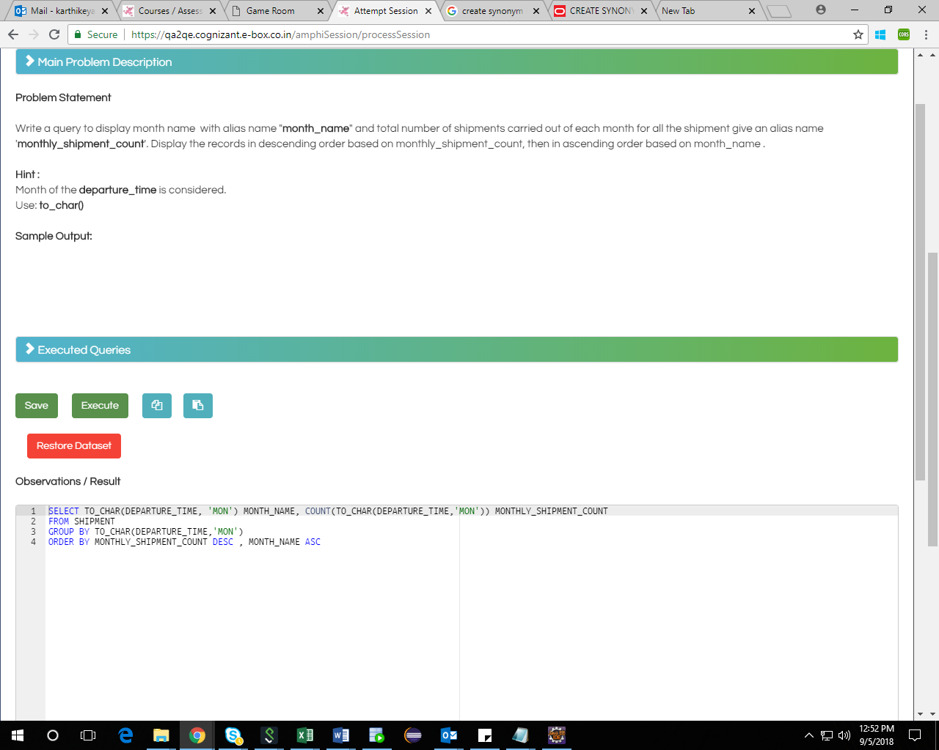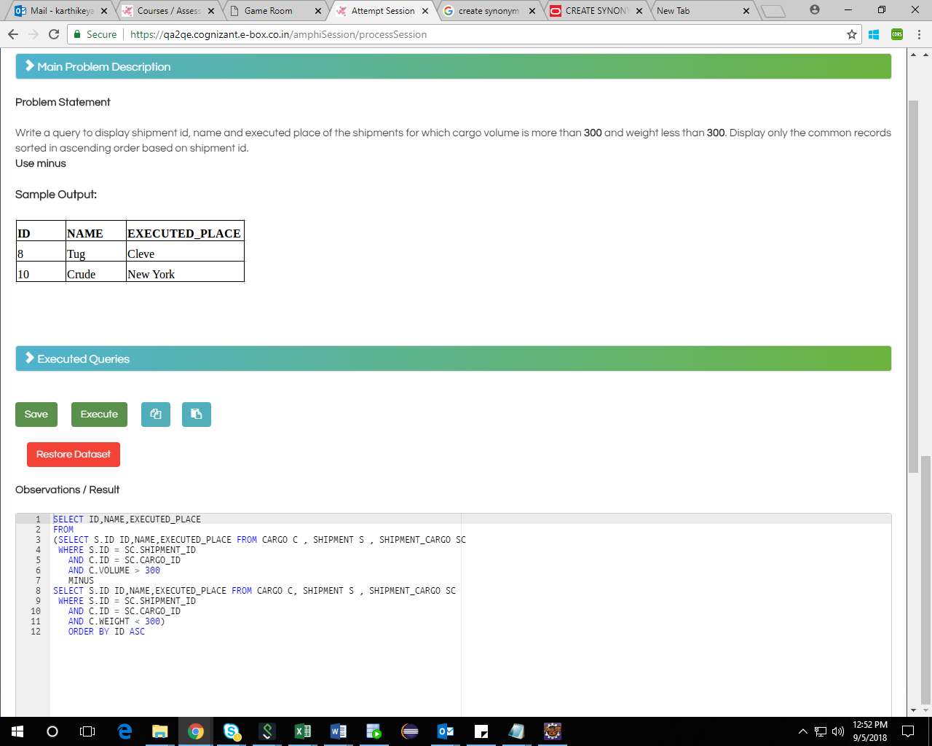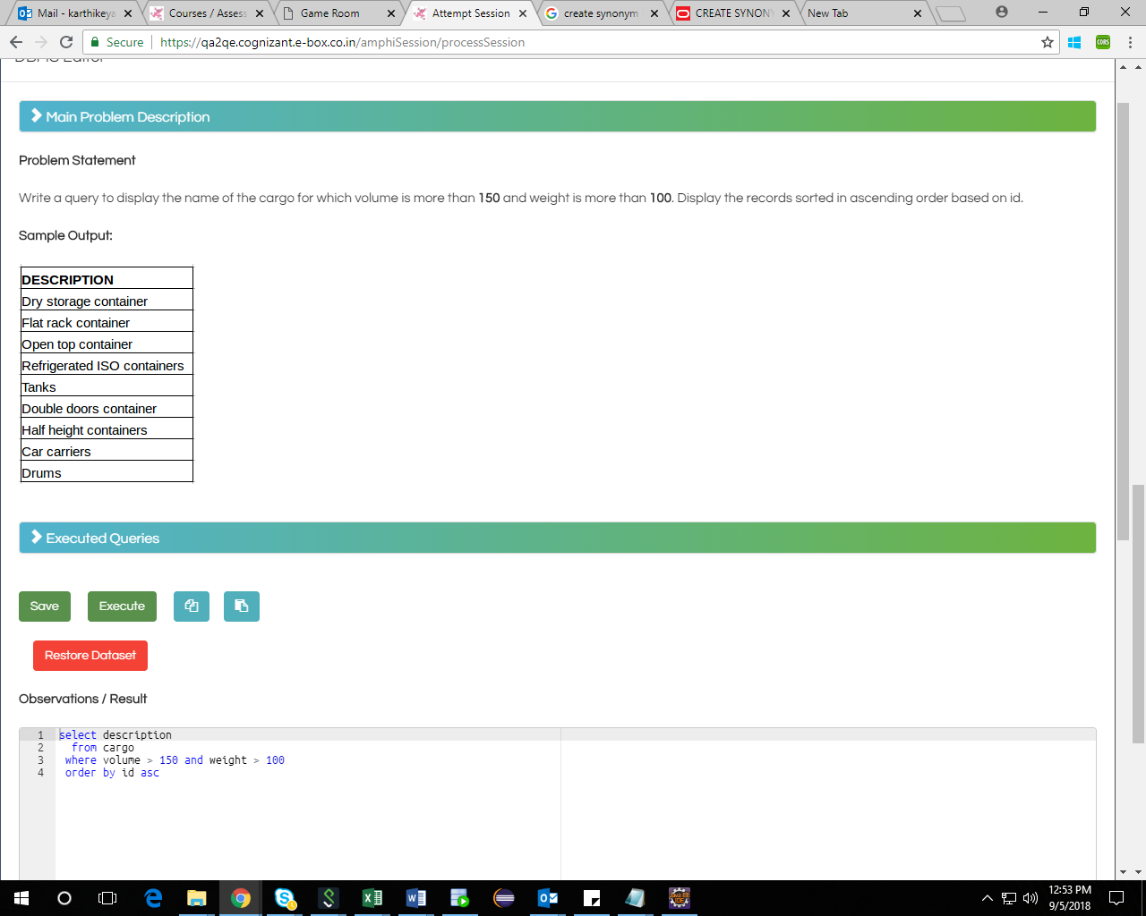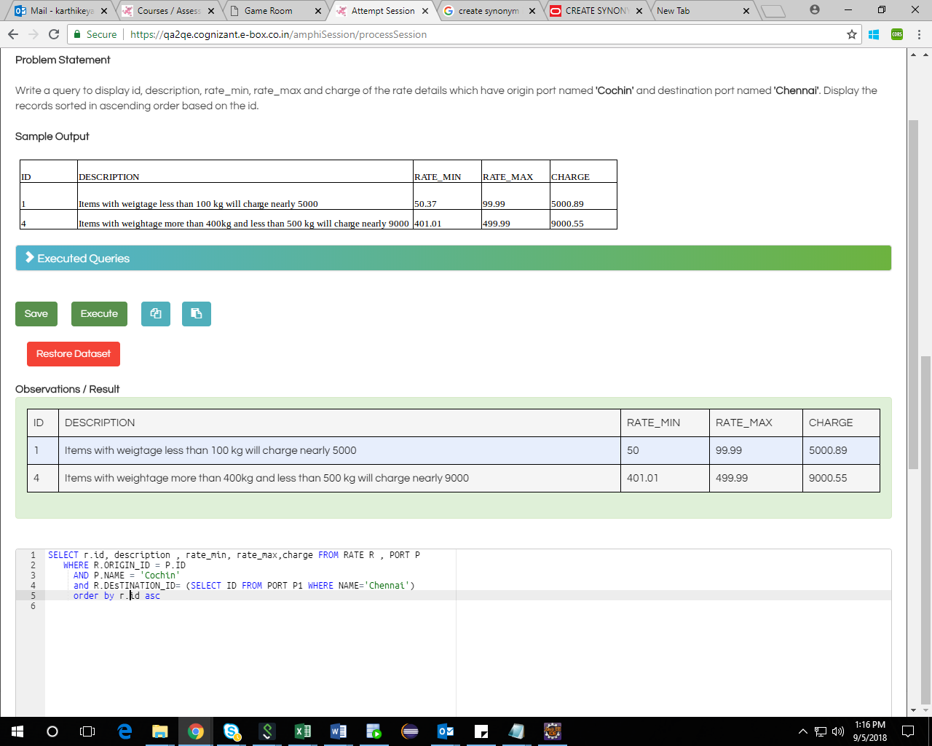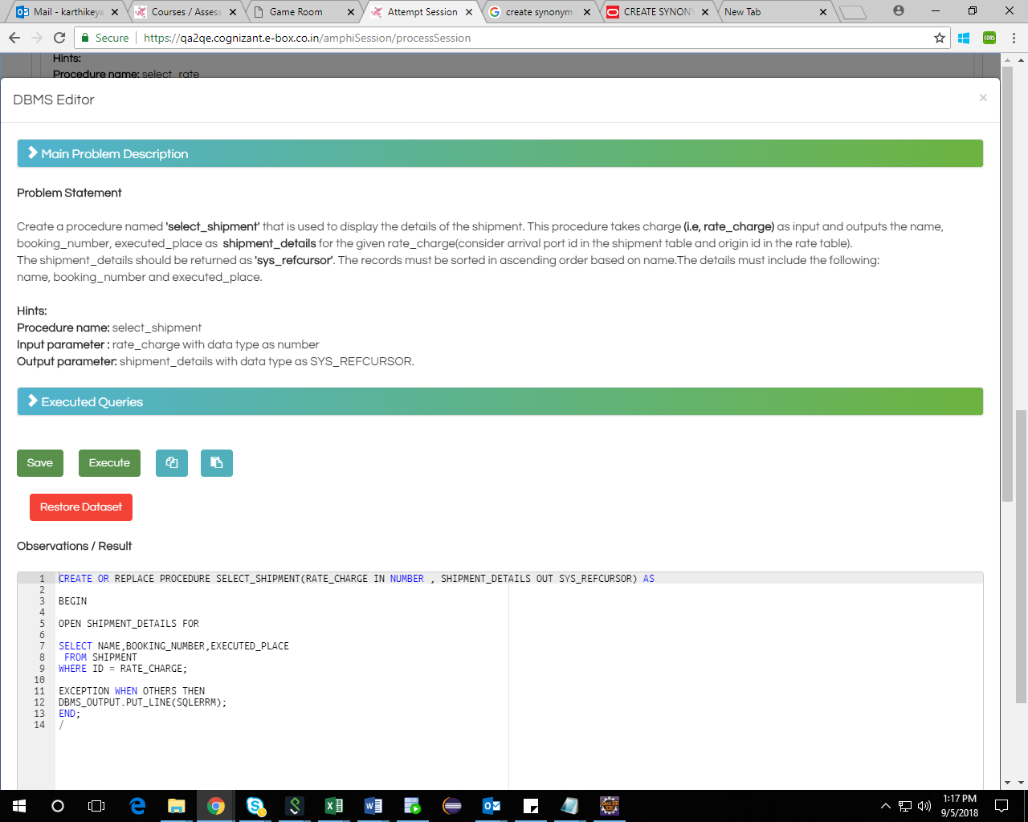

Refcursor question 